Lab 1 : Computer Network : Vedanth Mapakshi

1. **Research on various virtualization software**

VMware: Vmware is a non-open source virtualiazation software which can be run on windows, linux and unix. Vmware has a limited graphics support and compared to that of Citrix Xenserver. Also, VMware requires individuals to have a license to use it. The following are the PC requirements to run VMware- Microsoft SQL Server 2008 R2. Up to 2GB free disk space to decompress the installation archive. The management kernel is completely custom made by VMware. It does not use Linux, UNIX, or POSIX.

Virtualbox: Oracle VM Virtualbox is a cross-platform virtualizer for x86 servers and desktops, and embedded usage. With this product, you can run multiple operating systems on a single machine, all at the same time, making it a powerful tool to test, develop, demonstrate and deploy solutions. Oracle VM Virtualbox is a professional solution that is also freely available as Open Source Software. It is for both enterprise and home use. This x86 and AMD64/Intel64 virtualization software is high performing and rich in features. Oracle VM Virtualbox currently runs on Windows, Linux, Solaris and Macintosh. It also supports many guest operating systems, such as Windows, DOX/Windows 3. Linux, OS/2, OpenBSD, Solaris and OpenSolaris.

Citrix Xenserver: Citrix XenServer is an open source virtualization platform that manages server, desktop and cloud virtual infrastructures. XenServer lowers IT costs and increases IT agility and flexibility. The maximum limit per host for XenServer is 1000. XenServer is an enterprise-ready, cloud-proven virtualization platform with all the capabilities needed to create and manage a virtual infrastructure using XenCenter® management console.

1. **My Choice:**

The virtualization software I chose is Oracle's Virtual box as I already had a good knowledge about the workings of it and it was well compatible with my laptop. The fact that it is open sourced and does not require as much space to be installed and configured as compared to the other two softwares also pointed me towards making use so it. The biggest feature that I like and which is most valuable for me is the fact that Virtualbox is easy to set up, it's ready to go, and we can install images on a Linux OS in a fairly quick and efficient time with minimal manual work. The ability to spring up test environments in a quick and eligible manner also contributed to my choice. Ease of use, versatality and compatibility were important factors that affected my decision to go for Oracle's virtual box.

1. **Steps Followed to set up mail server:**

To setup the mail server, I first started by setting up the domain name and hostname and then rebooting my system to implement the changes. Next, I performed an update and an upgrade. After that I installed postfix through the terminal. After the installation, I first did a basic reconfiguration of postfix. Then, I opened the main.cf file and added some more configurations to it such as configuring the mailbox format and configuring postfix for SMTP_AUTH using SASL. Next, I generated a certificate for TLS using a certificate authority. After that, I configured postfix to provide TLS encryption for both incoming and outgoing mails. With postfix's initial configuration done, I moved on to configuring SASL. Out of the two SASL implementations that postfix supports I chose dovecot SASL. I installed dovecot-core from the terminal and after doing so, first I reconfigured the 10-master.conf file then I reconfigured the authentication mechanisms of the 10-auth.conf file. After that, I rebooted the dovecot service to implement the changes. Next I installed a mail stack delivery package which configured dovecot for imap, imaps, pop3 and pop3s. Finally I tested the mail server using the telnet command from the terminal to check for an established connection to port 25 of my mail domain and tested if everything works perfectly using the ehlo command.

I followed the instructions povided in the source below:

https://help.ubuntu.com/lts/serverguide/postfix.html

1. **Host machine ipconfig**

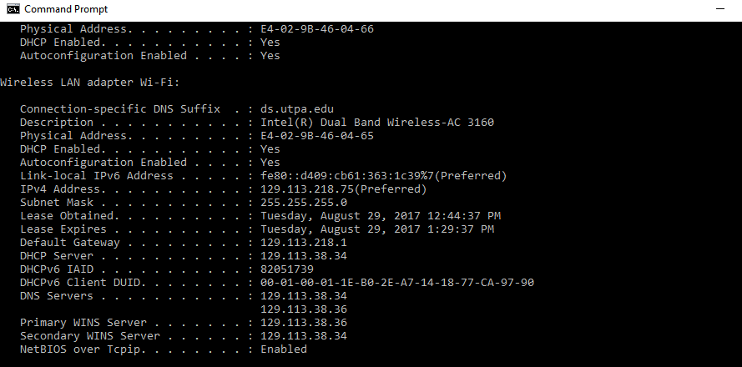

1. **Virtual machine ifconfig**

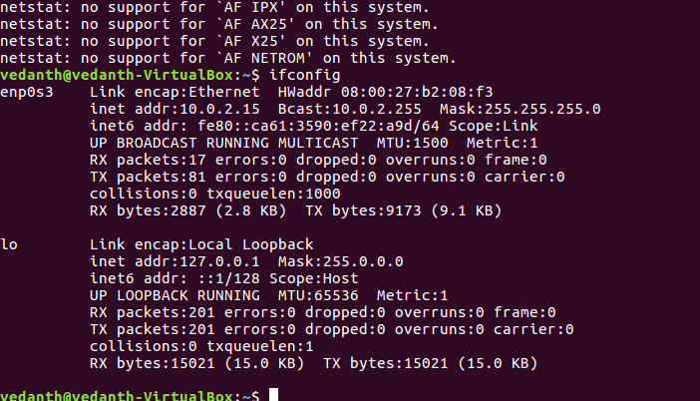

1. **Cp**

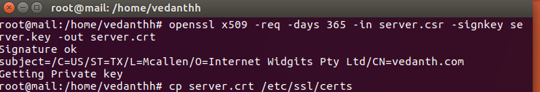

1. **Netstat**

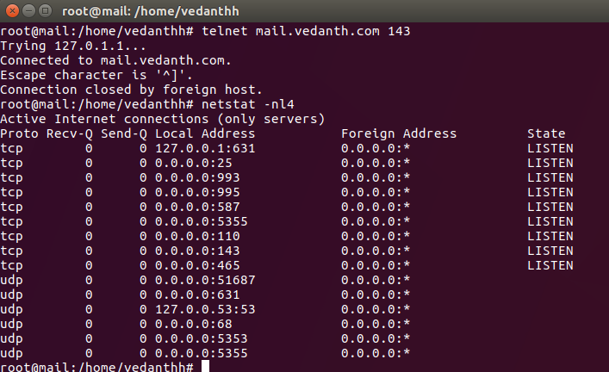

1. Telnet and ehlo to test if server is working

